How to Authorize a Gator 1 Card:

First I go to card services at this webpage:
https://www.bsd.ufl.edu/G1CO/IPay1f/start.aspx?TASK=FACSTAFFAPPROVE

I select ID Card Authorization from the dropdown then press “GO”

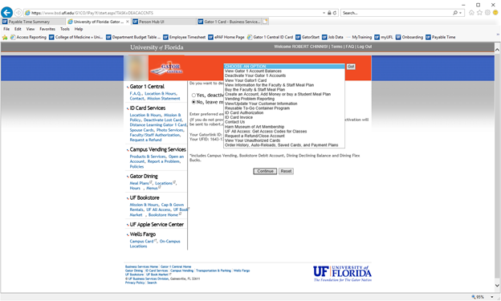

Then we enter the UFID and press Lookup UFID
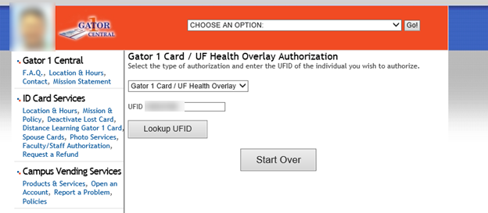

The person’s name autopopulates.
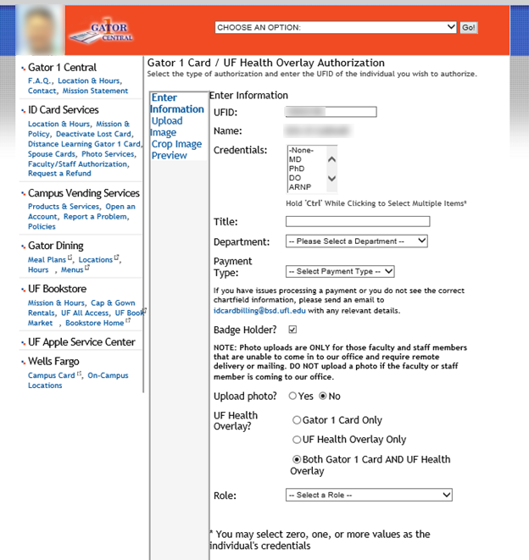

Then I make the necessary selections.

First go to bottom and choose if this is a Gator 1 Card only; UF Health Overlay only or Both
Then:
- Credentials
- Title – we type this in manually
- Select Department from a dropdown list
- Select payment type
- Check badge holder if needed
- Click upload photo
- Select Role from a dropdown list

Then click Next
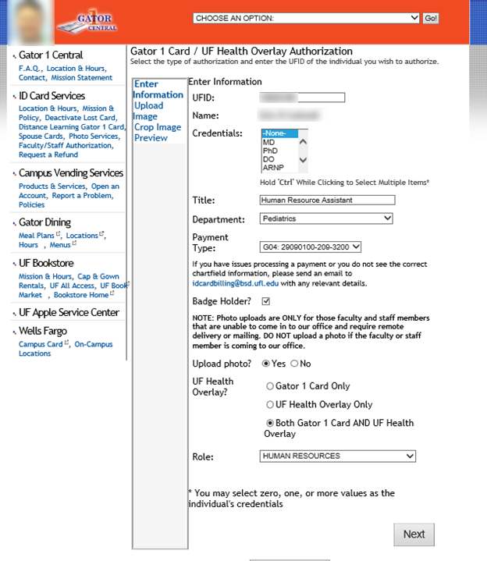

On the next screen we upload the photo by clicking Browse and choosing one from a file and then click next:

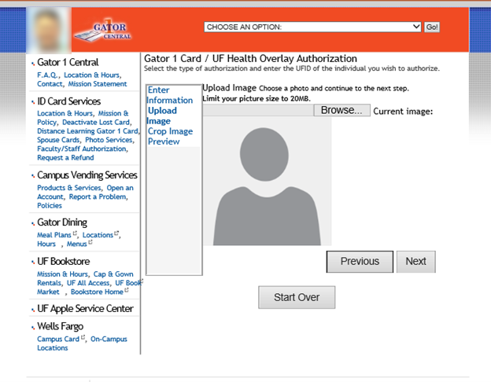

Then we are given the option to crop the image but that is very limited in what can be done, and hit next:

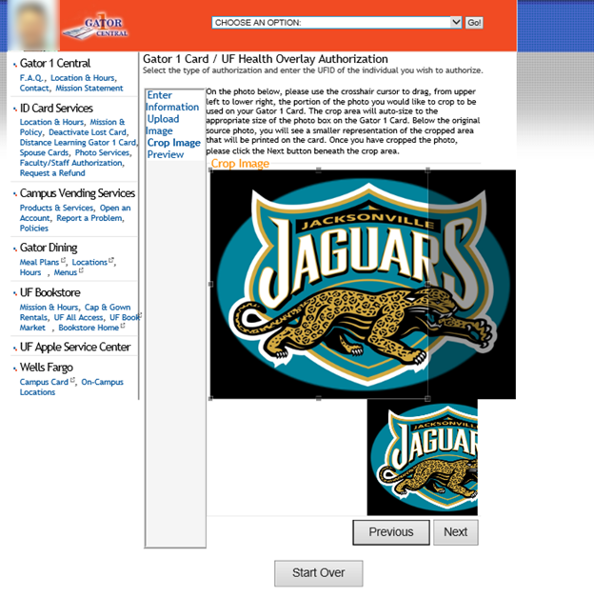

Finally we chose which office the order is going to:

